**Data Story 2: Who Has Been Studied**

The Suicide Prevention Trials Database (SPTD) was designed to identify studies of suicide prevention interventions and abstract detailed study-level data in a standardized manner into a publicly accessible database. Many aspects of this project are based on a similar database for studies of PTSD treatment trials, the PTSD-Repository, available through the National Center for PTSD at [PTSD-Repository (socrata.com)](https://ptsd-va.data.socrata.com/). The first phase of the SPTD included data from randomized control trials (RCTs) that were published between 1980 and 2023 with a primary aim of preventing suicide or suicidal self-directed violence. RCTs are one of the best scientific methods for testing the effectiveness of an intervention. In an RCT, participants are assigned at random to an intervention group or a control/comparison group. The random assignment of study participants helps balance participant characteristics across the groups. This increases the confidence that differences in outcomes between the intervention and control/comparison groups are due to the intervention rather than participant characteristics (i.e., “confounders”).

The following data story examines the sample characteristics of the 140 studies included in Phase 1 of SPTD and can help us better understand what populations have been targets of suicide prevention interventions. This data story presents study level information on participants for several characteristics.

**Suicide Inclusion Category**

The *suicide inclusion category* variable categorizes studies as *indicated,* *selected, or universal* based on suicide-risk related participant inclusion criteria.

* Indicated studies are those that included participants with history of suicidal ideation, nonfatal suicide attempts, or psychiatric hospitalization. Most studies (n = 118; 84.3%) had a suicide inclusion criterion of indicated.
* Selected studies are those that included participants with characteristics indicating risk for suicidal ideation, nonfatal suicide attempts, or psychiatric hospitalization but no history of these outcomes. The remaining 22 (15.7%) studies has a suicide inclusion category of selected.
* Universal studies are those that included participants with no previously known risk for suicidal ideation, nonfatal suicide attempts, or psychiatric hospitalization. No studies were in this category.

**Study Site Category**

SPTD Phase 1 Dataset; N = 140 Studies

**Studies by Suicide Inclusion Category**

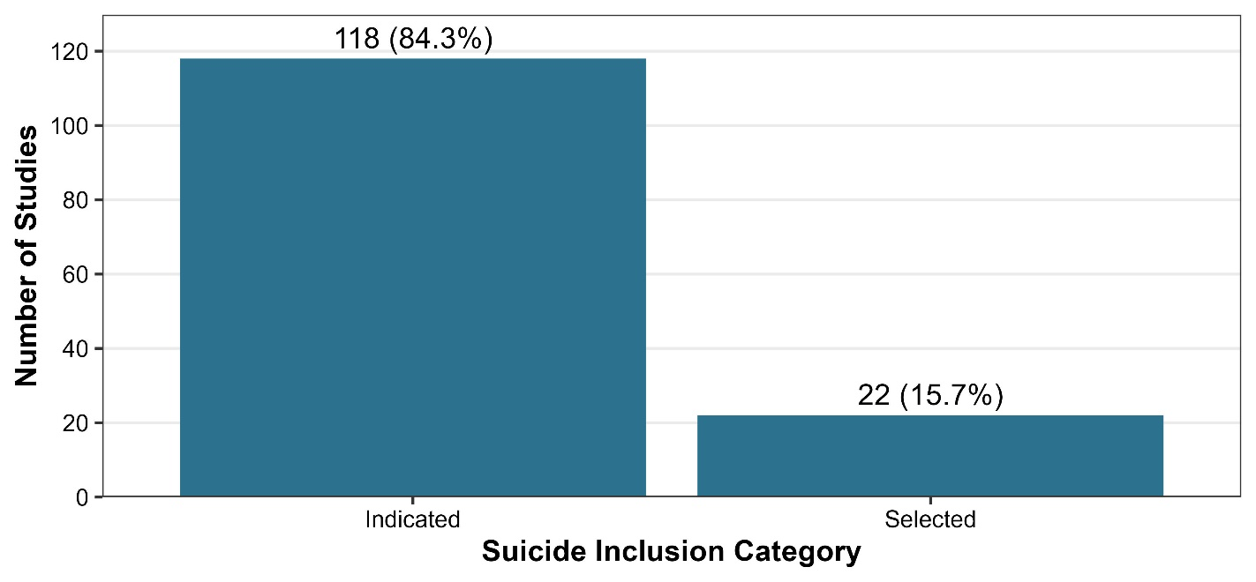

The study site category describes where the study took place with the options of Civilian, Military/Department of Defense (DoD), Veterans Affairs (VA), or Other.

Most studies in Phase 1 of SPTD took place at civilian sites (n = 121, 86.4%). However, this does not preclude that there may be veterans or active-duty military in the sample. One site was categorized as other. Of the remaining 18 (12.0%) studies, seven (5.0%) took place at a DoD site, and ten (7.1%) took place at a VA site.

**Studies by Site Category**

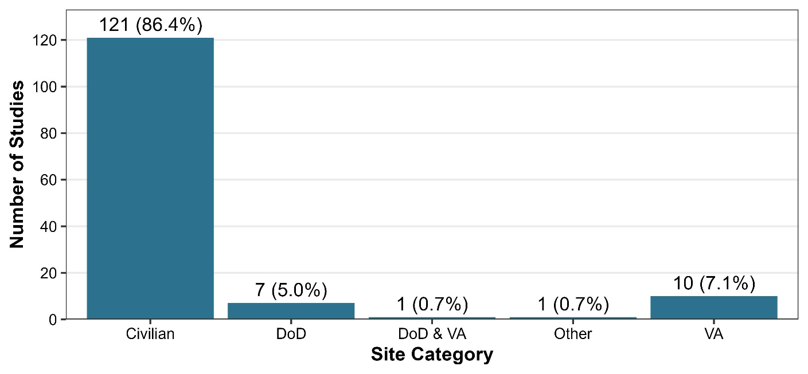

SPTD Phase 1 Dataset; N = 140 Studies

**Mean Age of Study Sample**

The mean age of study sample was extractable for 120 (85.7%) studies. The average of the study-reported mean ages in SPTD Phase 1 was 34.5 years of age. The first phase of SPTD only included studies on adults.

**Studies by Mean Age of Study Sample**

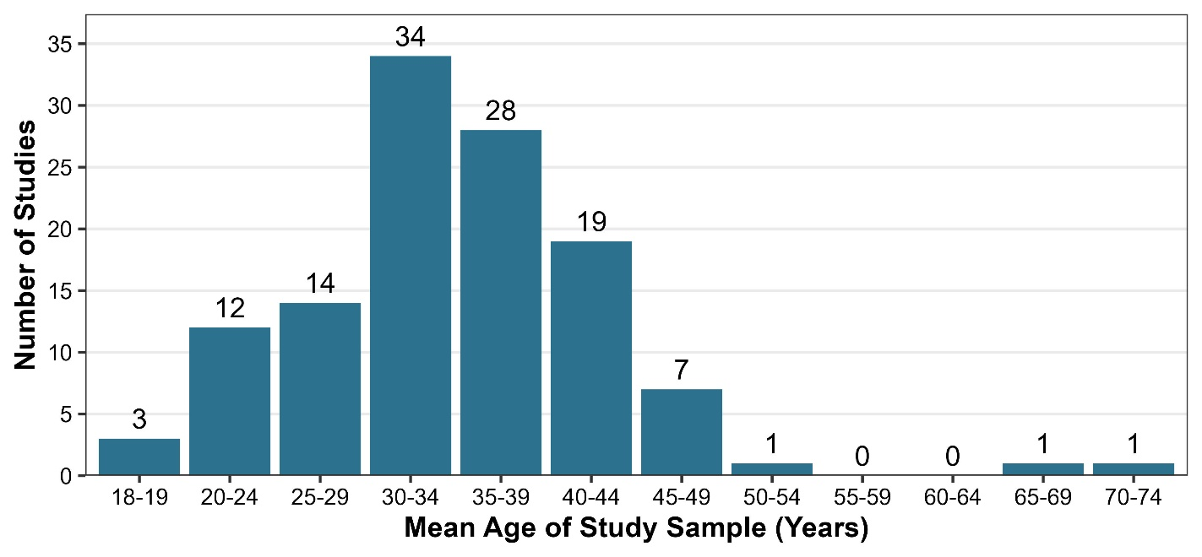

SPTD Phase 1 Dataset; N = 140 Studies

**Number of Studies by Mean Age of Sample and Military Site Category**

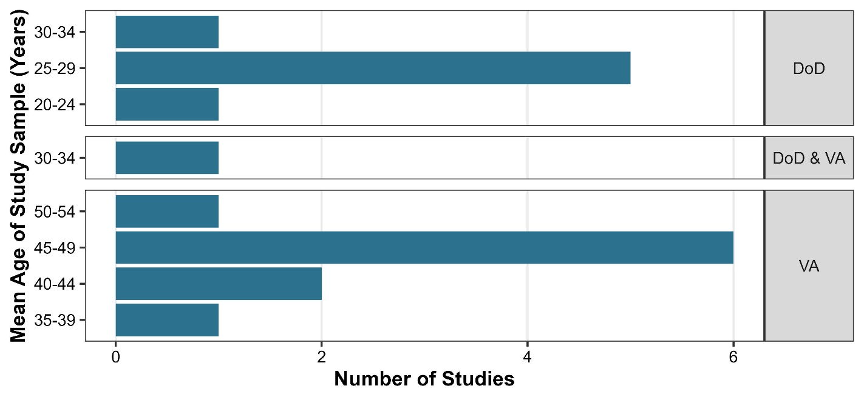

SPTD Phase One Dataset N = 140 Studies

Phase 1 of SPTD had seven studies with a Department of Defense site category. As expected, the average of the mean ages of these seven DoD studies (26.8 years of age) was younger than that of the VA studies (45.8 years of age).

**Race and Ethnicity**

Race and Ethnicity are social constructs that vary by region and country. Due to this wide variation and the need to create comparable data across studies, race and ethnicity are categorized in SPTD following the United States Office of Management and Budget (OMB) standards.

For race, the OMB standard has 5 categories: Asian, American Indian Alaska Native, Black, Native Hawaiian or Other Pacific Islander, White. In addition to these categories SPTD also has a field for “Other” which can include other, multiple races, and Hispanic.

The OMB standard for ethnicity is a single category of Hispanic or Latino. Only 24 studies (17.1%) reported data on race but not ethnicity, and 33 studies (23.6%) reported data on race and ethnicity; 83 studies (59.3%) did not report race/ethnicity data according to the OMB standard.

Of the 33 studies which reported race and ethnicity data according to the OMB standard, 30 took place in the United States, while the other three took place across multiple countries. Studies from Canada, New Zealand, South Africa, United Kingdom, and United States as well as one study in multiple countries reported race data using non-OMB categories. Over time there was an increase in studies reporting OMB-standard race and ethnicity data.

**Studies Reporting Race and Ethnicity**

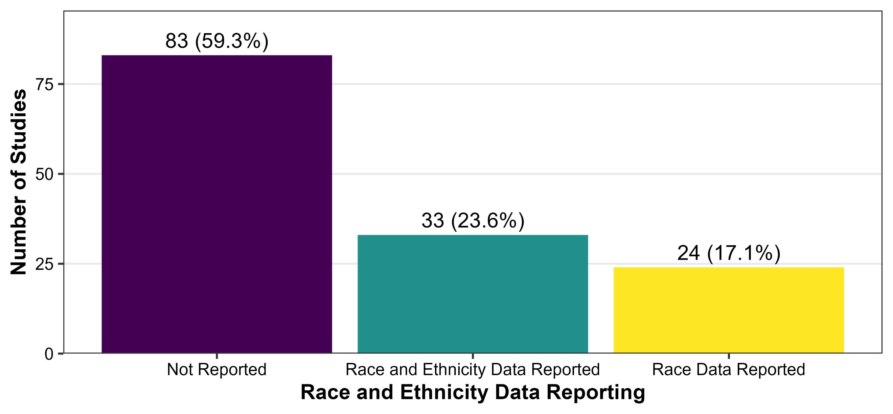

SPTD Phase One Dataset N = 140 Studies

Race and Ethnicity are categorized in SPTD following the United States Office of Management and Budget (OMB) standards. The OMB has five categories for race: Asian, American Indian Alaska Native, Black, Native Hawaiian or Other Pacific Islander, White. The OMB has one category for ethnicity, Hispanic or Latino.

Race and Ethnicity are categorized in SPTD following the United States Office of Management and Budget (OMB) standards. The OMB has five categories for race: Asian, American Indian Alaska Native, Black, Native Hawaiian or Other Pacific Islander, White. The OMB has one category for ethnicity, Hispanic or Latino.

**Studies Reporting Race and Ethnicity by Decade**

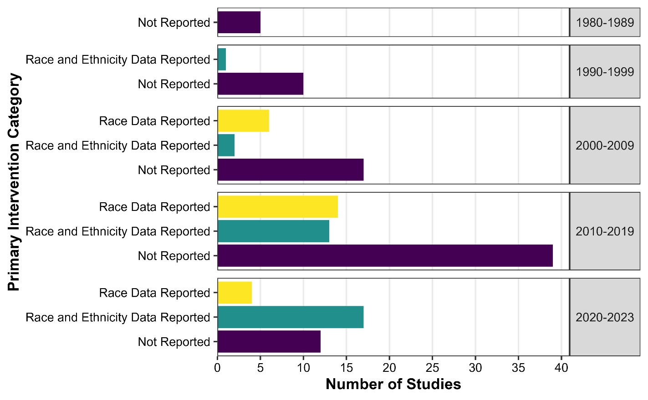

SPTD Phase One Dataset N = 140 Studies

**Location of Studies**

The *country* variable indicates the country (or countries) in which study participants lived. Studies took place in 26 distinct countries. The three most common countries were United States (n = 47, 33.6%), United Kingdom (n = 17, 12.1%), and Australia (n = 11, 7.9%). Seven (5.0%) studies took place across multiple countries.

**Studies by Country**

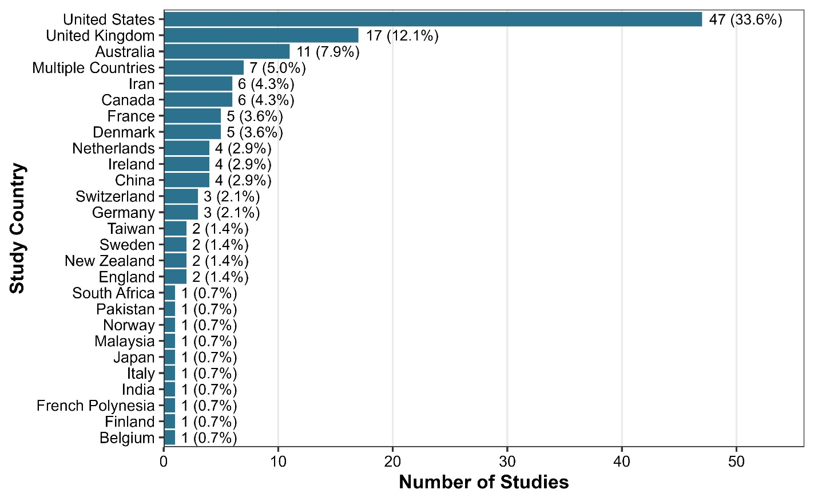

SPTD Phase One Dataset N = 140 Studies

The Multiple Countries category includes studies that took place in more than one category e.g., Australia, Canada, and United States.

**Gender of Study Participants**

The *percent of women* variable provides an indication of the percent of study participants who were categorized as female (sex at birth) and/or women (frequently not enough information is provided to discern true gender identity). In the SPTD 3.5% of trials did not report the percent of participants that were women. The majority of studies (82; 58.6%) had a sample between 50-79% women. Nine studies enrolled 100% women, and only two studies enrolled 100% men. With the exception of one VA study that had a sample of 84.2% women, studies at VA or DoD settings category had less than 50% women, and 12 of 18 had less than 20% women.

**Studies by Percentage of Women in Study Sample**

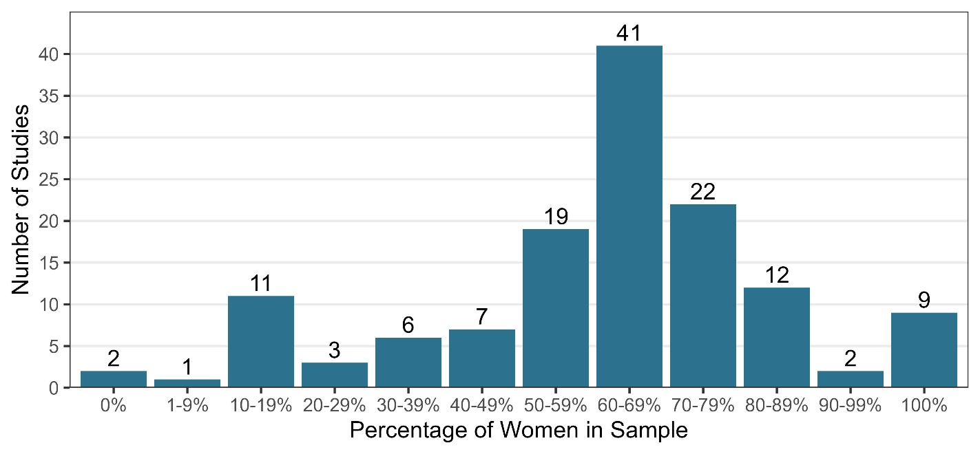

SPTD Phase One Dataset N = 140 Studies

**Percent of Women in Study Sample by Military Site Category**

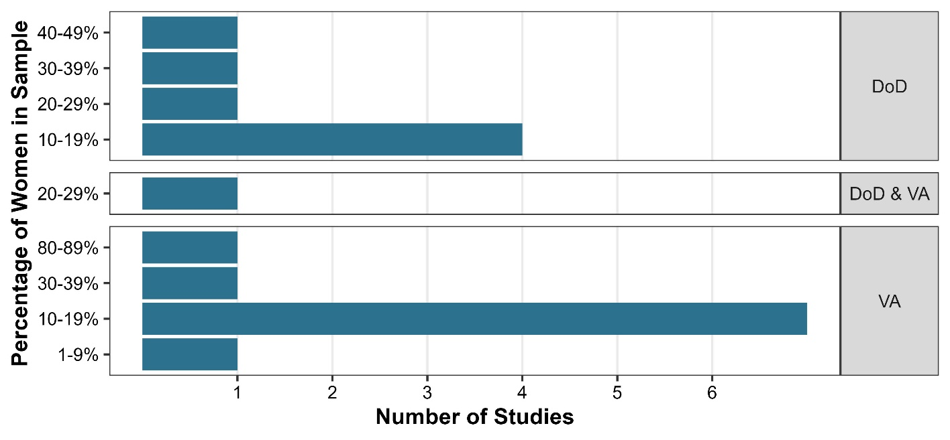

SPTD Phase 1 Dataset; N = 140 Studies

**Suicide Attempt History**

The *percent of sample with suicide attempt history* variable indicates the percent of participants in the study sample that had a history of one or more suicide attempts or self-harm events prior to study enrollment.

* There were 104 studies which reported the percent of participants with suicide attempt history.
* There were 61 studies where 100% of the study sample had history of a suicide attempt or self-harm event at baseline.

**Percent of Sample with Suicide Attempt History**

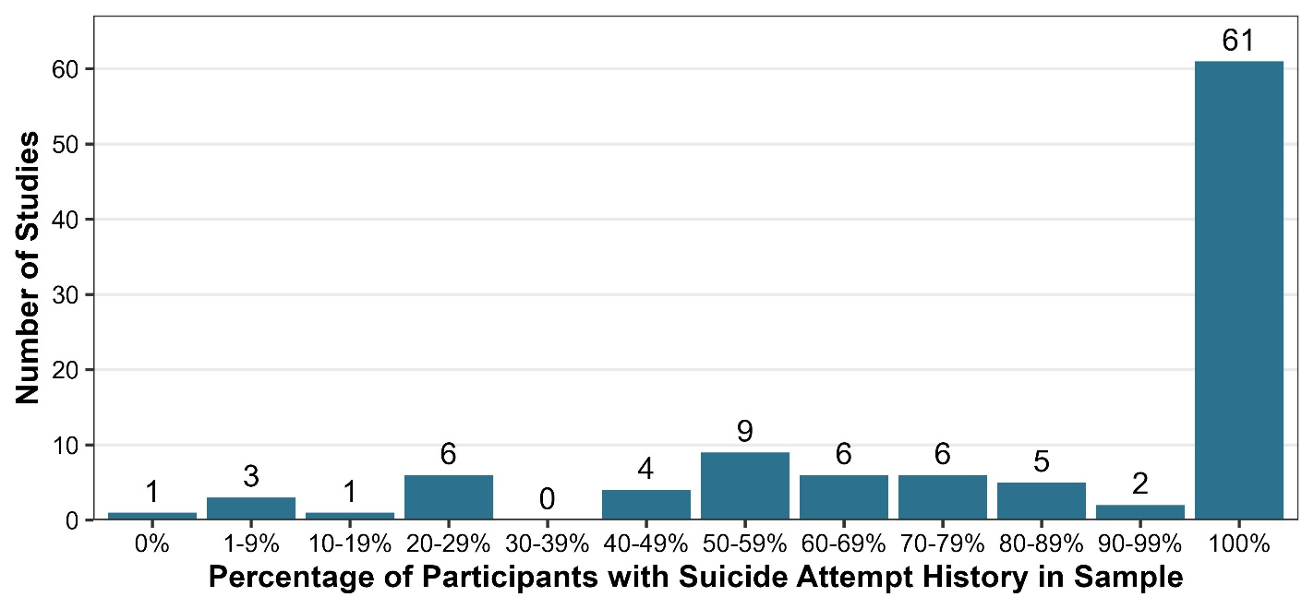

SPTD Phase 1 Dataset; N = 140 Studies

**Suicide Attempt History in VA/DoD Settings**

Compared to all studies in the SPTD, the studies that occurred at VA and DoD sites had a lower suicide attempt history percentage. The most frequent category in DoD studies was 50-59% followed by 100% suicide attempt history, while the most frequent category for VA studies was “not reported” followed by 80-89% suicide attempt history.

**Percent of Sample with Suicide Attempt History by Military Site Category**

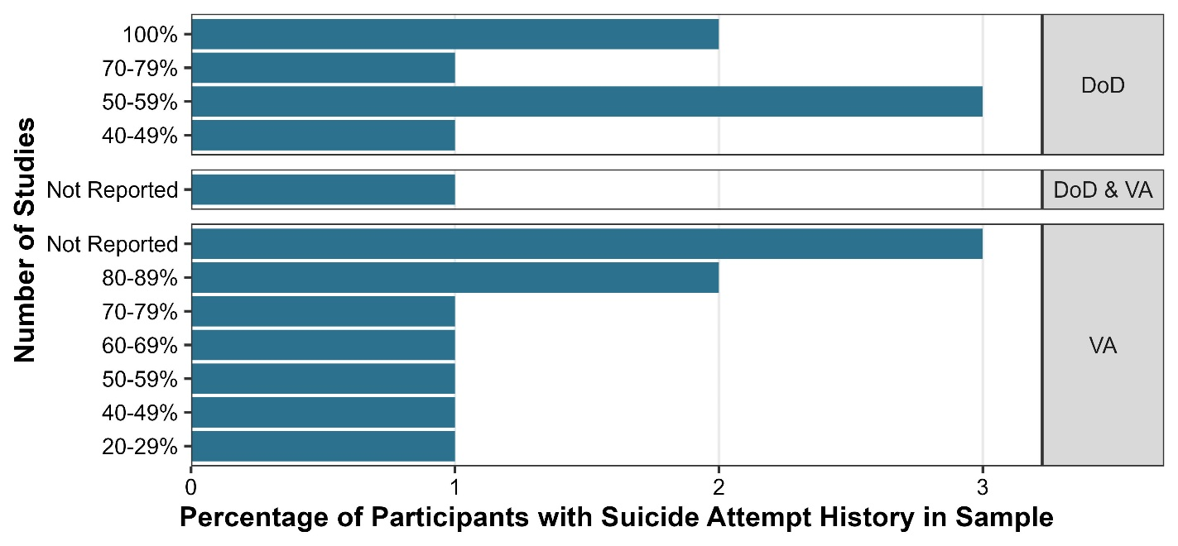

SPTD Phase 1 Dataset; N = 140 Studies

**Mental Health Disorders**

Studies reporting mental health disorders indicates which studies describe mental health-related conditions of enrolled participants. Note that the numbers in the following table represent the studies reporting these data, and not the percent of participants who have these conditions, though those values are included in the SPTD database. The SPTD tracks reporting of the following mental health-related conditions: Anxiety, Bipolar disorder, Borderline personality disorder, Other personality disorders, Psychosis, Post traumatic stress disorder, Substance use disorders, and Traumatic brain injury. The number of studies reporting mental health-related disorders also includes study inclusion and exclusion criteria. For example, if a study excluded patients with psychosis the percent of study participants with psychosis would be recorded as 0%, and the study would be recorded as reporting psychosis.

**Studies Reporting Mental Health Disorders of Enrolled Participants**

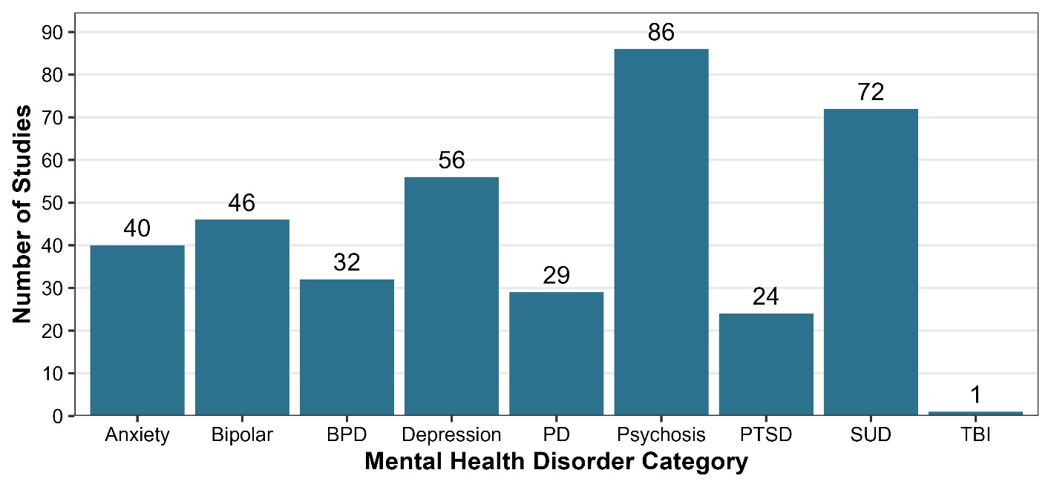

SPTD Phase One Dataset N = 140 Studies

BPD = Borderline Personality Disorder, PD = Personality Disorder, PTSD = Posttraumatic Stress Disorder,

SUD = Substance Use Disorder, TBI = Traumatic Brain Injury.

Funding Statement

This material is based upon work supported by the United States Department of Veterans Affairs, Veterans Health Administration, and VA Clinical Sciences Research & Development (CSR&D) project SDR-SPTD-20S. Lauren M. Denneson, PhD and Maya E. O’Neil are core investigators with the VA Portland Health Care System, HSR&D Center to Improve Veteran Involvement in Care (CIVIC). The views expressed in this report are those of the authors and do not necessarily reflect the position or policy of the Department of Veterans Affairs or United States government.

Citation

O’Neil, M.E., Baker-Robinson, W., Hannon, S., Krushnic, D., Veazie, S., Adams, J., Mcdonald, K., Willis, K., Jungbauer, R., O’Shea, B., Carlson, K., Hamblen, J., Denneson, L. (2023). *Suicide Prevention Trials Database Data Story 2, Who Has Been Studied.* Technical Report. VA, VHA, VA CSR&D Project # SDR-SPTD-20S; 2023. [https://www.hsrd.research.va.gov/centers/core/sprint/sptd.cfm](https://gcc02.safelinks.protection.outlook.com/?url=https%3A%2F%2Fwww.hsrd.research.va.gov%2Fcenters%2Fcore%2Fsprint%2Fsptd.cfm&data=05%7C01%7C%7C13253020b2064f6b172a08db1b4b6af6%7Ce95f1b23abaf45ee821db7ab251ab3bf%7C0%7C0%7C638133782945226402%7CUnknown%7CTWFpbGZsb3d8eyJWIjoiMC4wLjAwMDAiLCJQIjoiV2luMzIiLCJBTiI6Ik1haWwiLCJXVCI6Mn0%3D%7C3000%7C%7C%7C&sdata=vyWq2qO03j4qubMc%2B4vboodNnKnHjpDlIH7zqzDMEVY%3D&reserved=0)